**Lab No. 7**

**Department of Electrical Engineering**

|  |  |
| --- | --- |
| **Faculty Member:____________________** | **Dated: ________________** |
| **Semester:_____________** | **Section: ________________** |

**EE-222: Microprocessor Systems**

**Writing Assembly Programs**

|  |  |  |  |  |
| --- | --- | --- | --- | --- |
| **Name** | **Reg. No.** | **Report Marks / 10** | **Viva Marks / 5** | **Total/15** |
|  |  |  |  |  |
|  |  |  |  |  |
|  |  |  |  |  |

**Objective:** Convert the following C codes to assembly language for IA-32.

Note: **go_i** is an enable signal. **n_i** is some initial value for number of counts.

**fib_o** is the final output value.

**Program 1:**

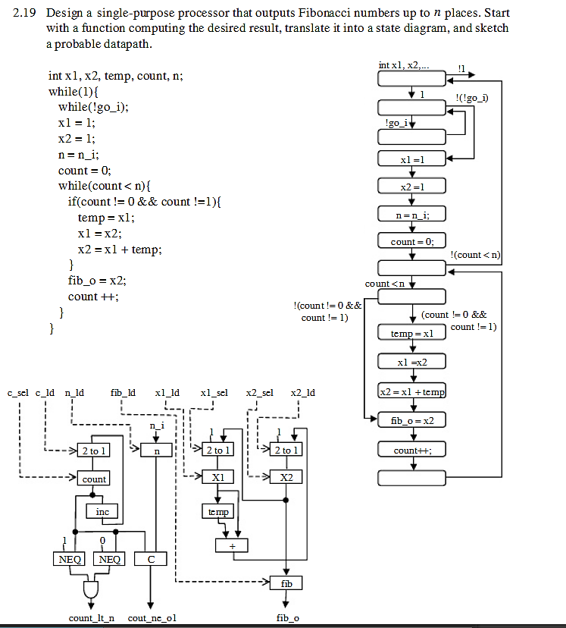 **[5 marks]**

**Program 2:**

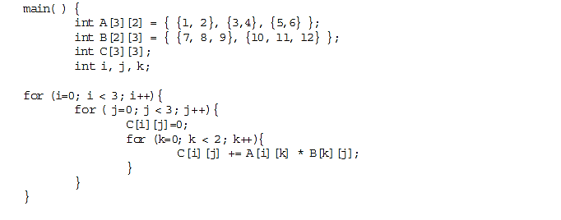 **[5 marks]**

**Note:** viva will taken at the end of lab carrying **5 marks**